MongoDb

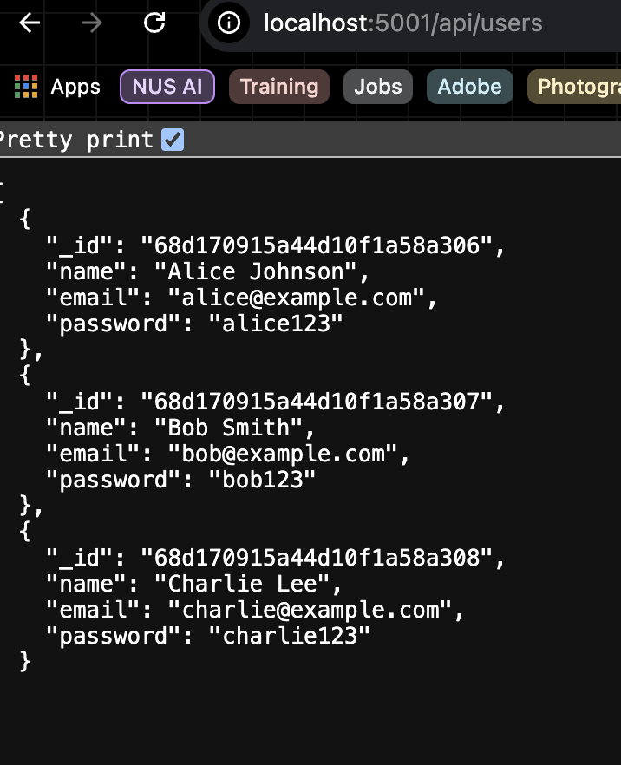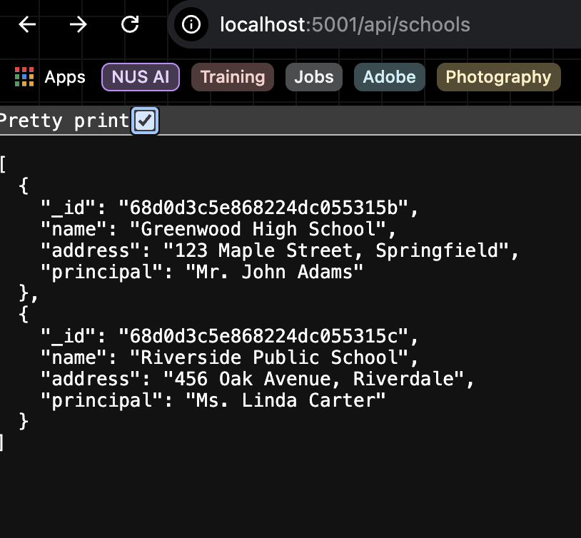

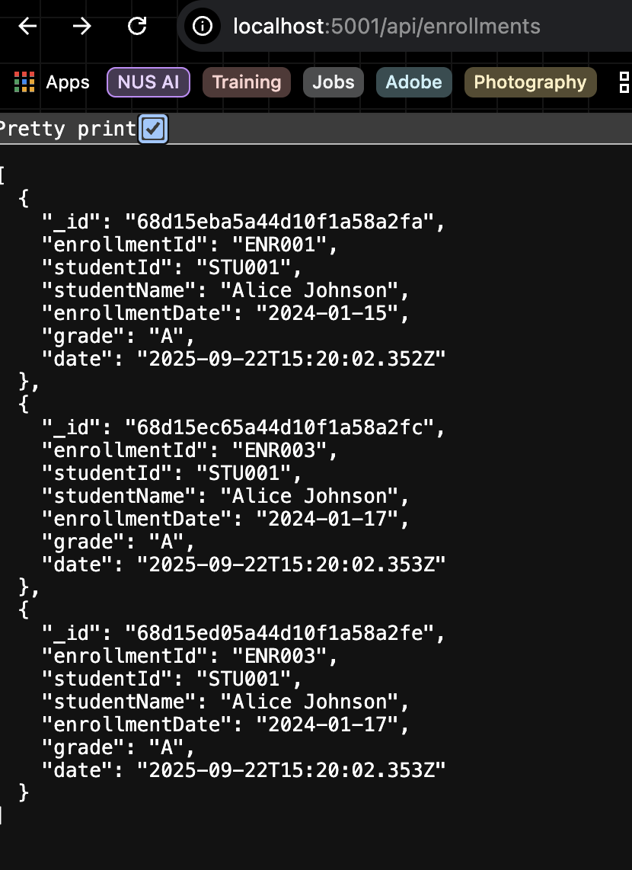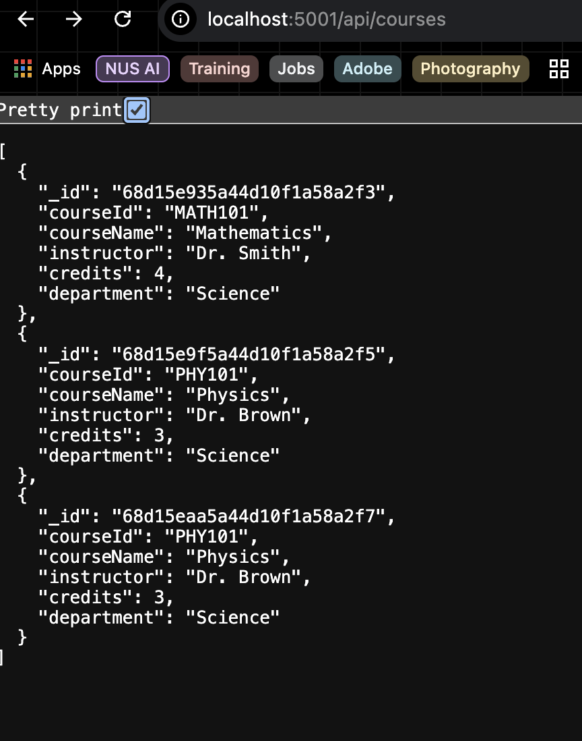

**Now perform the below task:**

1. Create a new entry in ‘school’ in MongoDB database and insert a document with the following parameter:

* “_id”
* “name”
* “address”
* “principal”

